**NAME OF SCHOOL: ................................................................................**

**NAME OF CANDIDATE: ..........................................................................**

**INDEX NO: ..................................... SIGNATURE: ................................**

**535/1**

**PHYSICS**

**Paper 1**

**JULY/AUGUST**

**2 ¼ hours**



**ELITE EXAMINATION BUREAU MOCK 2019**

**Uganda Certificate of Education**

**PHYSICS**

**PAPER 1**

2 HOURS 15 MINUTES

**INSTRUCTIONS TO CANDIDATES:**

* *Write the name of your school, your name, signature and index number clearly in the spaces above.*
* *Section A contains 40 objective type questions. You are required to write the correct answer A, B, C or D against each question in the box on the right hand side.*
* *Section B contains 10 structured questions. Answers are to be written in the spaces provided on the question paper.*
* *Mathematical tables and silent non – programmable calculators may be used.*
* *Acceleration due to gravity = 10ms-****2.***
* *Specific heat capacity of water = 4200Jkg****-1****K****-1***.
* *Speed of sound in air = 330ms****-1***.
* *Speed of light in vacuum = 3.0 x 108ms****-1***.

**FOR EXAMINER’S USE ONLY**

|  |  |  |  |  |  |  |  |  |  |  |  |
| --- | --- | --- | --- | --- | --- | --- | --- | --- | --- | --- | --- |
| Q41 | Q42 | Q43 | Q44 | Q45 | Q46 | Q47 | Q48 | Q49 | Q50 | Q51 | Q52 |
|  |  |  |  |  |  |  |  |  |  |  |  |
|  |  |  |  |  |  |  |  |  |  |  |  |

**SECTION A: (40 MARKS)**

**Answer all the questions in this section.**

1. Heat loss by radiation in a vacuum flask is minimised by the

A. cork B. silvered walls

C. vacuum D. vacuum seal

2. Water waves are produced in a ripple tank using a vibrator of frequency 4KHz. Find the wave length of the waves if the speed of waves is 60ms**-1**.

A. 2.6 x 10**5**m B. 1.4 x 10**2**m

C. 1.5 x 10**-2**m D. 2.0 x 10**-2**m

3. Fig 1 shows a uniform meter rule XY which balances when a mass of 40g is hung 0.4m from the knife edge.

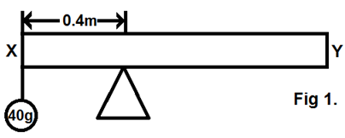

Calculate the mass of meter rule

A. 160g B. 100g C. 120g D. 220g

4. What energy changes take place when a switch of the electrical bell is pressed?

A. Electrical magnetic sound

B. Electrical sound magnetic

C. Chemical electrical sound

D. Electrical Chemical sound

5. In a transformer eddy currents reduce the efficiency by

A. producing heat in the core

B. producing magnetic field which is in the same direction as induced current.

C. producing magnetic field which opposes to flow of induced currents

D. creating magnetic reversals.

6. A piece of metal weights 30N in air and 20N when immersed in water. The metal weighs 22N when completely immersed in spirit. What is the density of the spirit in gcm**-3**?

A. 0.44 B. 0.10 C. 0.66 D. 0.80

7. The intensity of X – rays produced in the X – ray tube is controlled by

A. controlling the heating current of the filament.

B. adjusting the P.d between the anode and cathode.

C. increasing the number of cooling fins.

D. cooling the cathode.

8. A rider travelling at a constant acceleration of 2ms**-2** passes through two points P and Q in a straight line. If the speed at point P is 10ms**-1** and the points are 75m apart, find the speed at Q.

A. 18.2ms**-1** B. 21.0ms**-1**

C. 20.0ms**-1** D. 35.0ms**-1**

9. Which of the following actions will cause the leaf of a negatively charged gold leaf electroscope to collapse?

i) Bringing a negatively charged rod near the cap

ii) Bringing a positively charged rod near the cap.

iii) Bringing an insulator near the cap.

A. i) only B. ii) only

C. i) and iii) only D. i), ii) and iii)

10. When water waves travel from deep to shallow waters

A. velocity increase

B. wave length increase

C. frequency increases

D. both wave length and velocity decrease.

11. When soft iron is placed between the poles of a magnet,

A. the path of magnetic field is blocked.

B. the magnets become demagnetised.

C. magnetic field lines become concentrated.

D. more magnetism is induced in the magnet.

12. A body of mass 20kg falls from a height of 10m. What is its kinetic energy on hitting the ground?

A. 1000J B. 3000J C. 2500J D. 2000J

13. A water tank of length 2.0m and width 1.0m contains 10m**3** of water. What is the height of water in the tank?

A. 4.0m B. 5.0m C. 10.0m D. 8.0m

14. Which of the following is not a component of the nucleus of an atom?

i) electrons

ii) neutrons

iii) protons

A. i) and ii) only B. ii) and iii) only

C. i) only D. ii) only

15. Which of the following devices uses flow of current through a conductor in a magnetic field to produce motion?

A. Loud speaker B. Microphone

C. Dynamo D. Motor

16. A body of mass 20kg weighs 40N on planet M which of the following is true about planet M?

A. The mass of the body is less on M than on earth.

B. The mass of the body is greater on M than on earth.

C. The acceleration due to gravity on M is greater than that on earth.

D. The acceleration due to gravity on M is less than that on earth.

17. Figure 2 shows two electromagnets M and N close to one another. What is observed when switches K**1** and K**2** are closed?

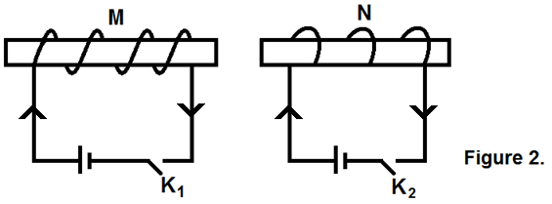

A. Attraction between M and N B. Repulsion between M and N.

C. No observable change D. Sparks and seen

18. Two objects A and B were hung at the end of a spring balance and gave the same reading. Which one of the following quantities is the same for both objects?

A. Weight B. Mass C. Density D. Volume

19. An object is placed 12cm from a convex lens of focal length 10cm. The image formed is

A. virtual and magnified B. real and magnified

C. virtual and diminished D. real and diminished

20. What is the velocity ratio of the pulley system in Figure 3?

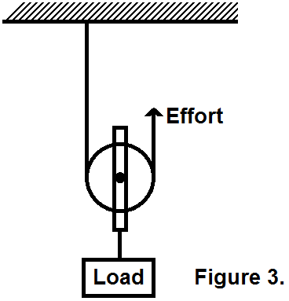

A. 1 B. 3 C. 2.5 D. 2

21.

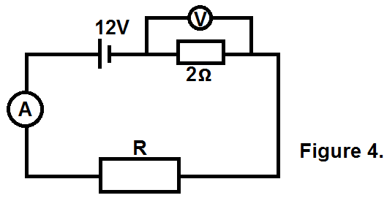

In Figure 4, the ammeter reads 4A and the voltmeter 4V. Find the value of R.

A. 1Ω B. 2Ω C. 3Ω D. 4Ω

22. The rate of diffusion can be increased by

A. lowering temperature

B. increasing the concentration of substance

C. adding oil to water

D. adding soap to water

23. A ray of light travelling from air to medium X is incident at an angle of 60**0**. If the angle of refraction is 25.7**0**, determine the critical angle for the medium.

A. 65.5**0** B. 60.1**0** C. 35.8**0** D. 30.0**0**

24. A radioactive substance, takes 12 years to decay to 80% of its original mass. What is its half-life?

A. 5.2 years B. 8.4 years

C. 6.0 years D. 2.6 years

25. Which of the following factors enables a small effort to lift a large load in a hydraulic press?

i) Pressure is transmitted equally in all directions.

ii) Small piston produces high pressure.

iii) The load experiences a large force.

A. i) and ii) only B. ii) and iii) only

C. i) and iii) only D. i), ii) and iii)

26. The work done in moving a coulomb of charge from one point to another in a circuit is a ………………..

A. joule B. ampere C. volt D. watt

27. Calculate the amount of heat needed to raise the temperature of 100g of iron from 20**0**C to 35**0**C. (Specific heat capacity of iron = 460Jkg**-1**K**-1**)

A. 500J B. 880J C. 720J D. 690J

28. A car has got a gear box with a driving wheel of 15 teeth and the driven wheel of 90 teeth. What is the velocity ratio of the gear box?

A. 0.16 B. 15 C. 6 D. 3

29. In a wire supporting a load, stress is given by

A.  B. 

C. force x area D. 

30. An inflated balloon containing one litre of a gas at 27**0**C and a pressure of

2 x 10**5** Pa rises to a certain height where the pressure of the gas is 6 x 10**5** Pa and a temperature of 15**0**C. Calculate the new volume of the gas.

A. 0.32 litres B. 0.86 litres

C. 2.6 litres D. 3.8 litres

31. When a magnet is moved towards and through a coil, e.m.f is induced in the coil because of;

A. attraction between the coil and the magnet

B. the magnetic field outside the coil

C. forces of repulsion between the magnet and the coil.

D. the magnetic field lines cutting the coil.

32. What is the appearance of blue book cover with a word “PHYSICS” written in Red on it under yellow light.

A. The cover appears blue and words yellow.

B. The cover appears yellow and words red.

C. The cover appears black and words red.

D. The cover appears red and words black.

33. A cube made of Oak has sides of length 15cm floats on water with 10.5cm of its depth below the water. Surface and with its side vertical. Determine the density of the Oak.

A. 750gcm**-3** B. 240gcm**-3**

C. 0.7gcm**-3** D. 0.95gcm**-3**

34. Which of the following is an advantage of a force pump over a lift pump?

A. A force pump does not use atmospheric pressure to raise water.

B. A force pump raises water to a level higher than that of a lift pump.

C. A force pump uses less energy than a lift pump.

D. A force pump has more valves than a lift pump.

35. Three security lamps each rated 120W are switched on every day for 8 hours. Find the cost of running the lamps for one month if a unit of electricity costs Shs1500.

A.  B. 

C. Shs 120 x 3 x 8 x 1500 D. 

36. In a simple cell, the source of electrons which constitute the electron current is the;

A. copper plate B. dilute sulphuric acid

C. zinc plate D. potassium dichromate

37. As a body is raised above the ground.

A. mass increases B. weight increases

C. kinetic energy increases D. potential energy increases

38. The turning effect of force is its

A. momentum B. moment

C. potential energy D. kinetic energy

39. A lightning conductor is made up of a thick copper strip because

A. Copper is cheap

B. Copper is a poor conductor of electricity.

C. Thickness reduces resistance to flow of charge

D. Thickness increases resistance of flow of charge.

40. A force of 4N stretches a spring by 2cm. Calculate the load needed to stretch the same spring by 12cm.

A. 32N B. 28N C. 24N D. 20N

**SECTION B: (40 MARKS)**

**Answer all questions in this section. All working must be shown clearly in the spaces provided.**

41. a) What is a real image? (1 mark)

**……………………………………………………………………………………….....**

**……………………………………………………………………………………….....**

**……………………………………………………………………………………….....**

b) In the space below draw a ray diagram showing how a concave mirror forms a real image. (3 marks)

c) State any two uses of curved mirrors. (1 mark)

**……………………………………………………………………………………….....**

**……………………………………………………………………………………….....**

**……………………………………………………………………………………….....**

**……………………………………………………………………………………….....**

42. a) Define the term relative density. (1 mark)

**……………………………………………………………………………………….....**

**……………………………………………………………………………………….....**

**……………………………………………………………………………………….....**

b) A piece of metal weighs 80N in air and 65N when completely immersed in water. Calculate the density of the piece of metal if density of water is 1000kgm**-3**. (3 marks)

**……………………………………………………………………………………….....**

**……………………………………………………………………………………….....**

**……………………………………………………………………………………….....**

**……………………………………………………………………………………….....**

**……………………………………………………………………………………….....**

**……………………………………………………………………………………….....**

43. a) What is a stationary wave? (1 mark)

**……………………………………………………………………………………….....**

**……………………………………………………………………………………….....**

**……………………………………………………………………………………….....**

b) State two features of a stationary wave. (1 mark)

**……………………………………………………………………………………….....**

**……………………………………………………………………………………….....**

**……………………………………………………………………………………….....**

**……………………………………………………………………………………….....**

c) State what happens to a sound note when

i) Frequency is increased. (1 mark)

**……………………………………………………………………………………….....**

**……………………………………………………………………………………….....**

**……………………………………………………………………………………….....**

**……………………………………………………………………………………….....**

ii) Amplitude is increased. (1 mark)

**……………………………………………………………………………………….....**

**……………………………………………………………………………………….....**

**……………………………………………………………………………………….....**

**……………………………………………………………………………………….....**

44. a) Define the term velocity. (1 mark)

**……………………………………………………………………………………….....**

**……………………………………………………………………………………….....**

**……………………………………………………………………………………….....**

b) The velocity time graph below shows the motion of a car.

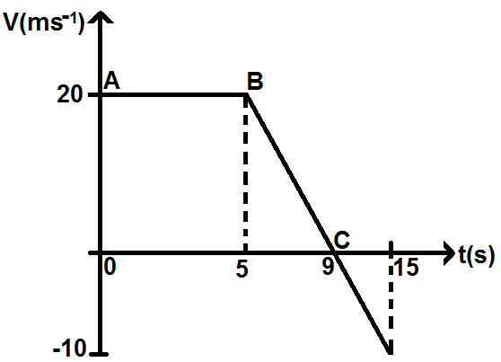

i) Describe the motion of the car. (2 marks)

**……………………………………………………………………………………….....**

**……………………………………………………………………………………….....**

**……………………………………………………………………………………….....**

**……………………………………………………………………………………….....**

ii) What is happening to the car at point C? (1 mark)

**……………………………………………………………………………………….....**

**……………………………………………………………………………………….....**

**……………………………………………………………………………………….....**

45. a) What is meant by the term thermionic emission? (1 mark)

**……………………………………………………………………………………….....**

**……………………………………………………………………………………….....**

**……………………………………………………………………………………….....**

b) In the space below draw and label the structure of cathode ray oscilloscope showing the 3 main parts. (2 marks)

c) State two dangers of radioactive substances. (1 mark)

**……………………………………………………………………………………….....**

**……………………………………………………………………………………….....**

**……………………………………………………………………………………….....**

**……………………………………………………………………………………….....**

46. a) Define the term electromotive force (e.m.f). (1 mark)

**……………………………………………………………………………………….....**

**……………………………………………………………………………………….....**

**……………………………………………………………………………………….....**

b)

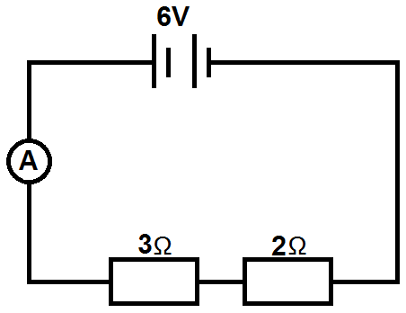Figure 5.

Figure 5, shows a battery of e.m.f 6V connected to two resistors of 3Ω and 2Ω. If a current of 0.8A flows in the circuit, calculate the internal resistance of cell.

**……………………………………………………………………………………….....**

**……………………………………………………………………………………….....**

**……………………………………………………………………………………….....**

**……………………………………………………………………………………….....**

**……………………………………………………………………………………….....**

**……………………………………………………………………………………….....**

**……………………………………………………………………………………….....**

47. a) State Charles’s law. (1 mark)

**……………………………………………………………………………………….....**

**……………………………………………………………………………………….....**

**……………………………………………………………………………………….....**

b) The graph of volume against temperature of a fixed mass of a gas at constant pressure is shown as below in figure 6.

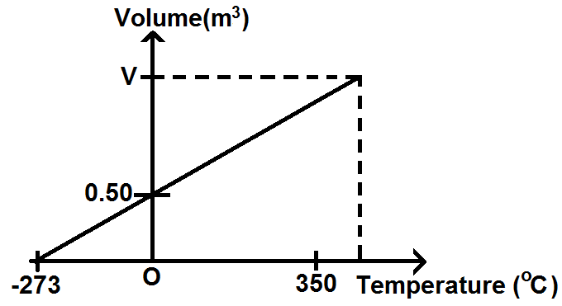

**Figure 6.**

Calculate the volume V of the graph. (3 marks)

**……………………………………………………………………………………….....**

**……………………………………………………………………………………….....**

**……………………………………………………………………………………….....**

**……………………………………………………………………………………….....**

**……………………………………………………………………………………….....**

**……………………………………………………………………………………….....**

**……………………………………………………………………………………….....**

**……………………………………………………………………………………….....**

48. a) Define work and state its unit. (2 marks)

**……………………………………………………………………………………….....**

**……………………………………………………………………………………….....**

**……………………………………………………………………………………….....**

b) A block of weights 3N moved from C to B on an incline plane as shown in the figure 7.

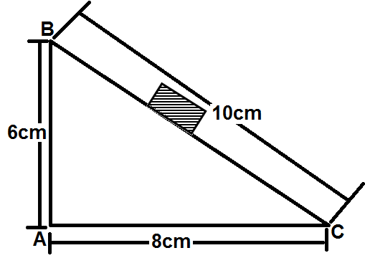

**Figure 7.**

If there is no frictional force, find the work done. (2 marks)

**……………………………………………………………………………………….....**

**……………………………………………………………………………………….....**

**……………………………………………………………………………………….....**

**……………………………………………………………………………………….....**

**……………………………………………………………………………………….....**

**……………………………………………………………………………………….....**

**……………………………………………………………………………………….....**

49. a) State Hookes’ law. (1 mark)

**……………………………………………………………………………………….....**

**……………………………………………………………………………………….....**

**……………………………………………………………………………………….....**

b) A spring produces an extension of 6mm when a load of 9N is hanged from it’s free end. What load would cause the same spring to stretch by 16mm? (3 marks)

**……………………………………………………………………………………….....**

**……………………………………………………………………………………….....**

**……………………………………………………………………………………….....**

**……………………………………………………………………………………….....**

**……………………………………………………………………………………….....**

**……………………………………………………………………………………….....**

50. a) i) Differentiate between scalar and vector quantities. (1 mark)

**……………………………………………………………………………………….....**

**……………………………………………………………………………………….....**

**……………………………………………………………………………………….....**

**……………………………………………………………………………………….....**

**……………………………………………………………………………………….....**

**……………………………………………………………………………………….....**

ii) Give one example of each quantity in (a) (i) above. (1 mark)

**……………………………………………………………………………………….....**

**……………………………………………………………………………………….....**

**……………………………………………………………………………………….....**

**……………………………………………………………………………………….....**

b) Two forces of 5N and 12N act on a body at right angles. Find their resultant force. (2 marks)

**……………………………………………………………………………………….....**

**……………………………………………………………………………………….....**

**……………………………………………………………………………………….....**

**……………………………………………………………………………………….....**

**……………………………………………………………………………………….....**

**……………………………………………………………………………………….....**

**……………………………………………………………………………………….....**

**END**